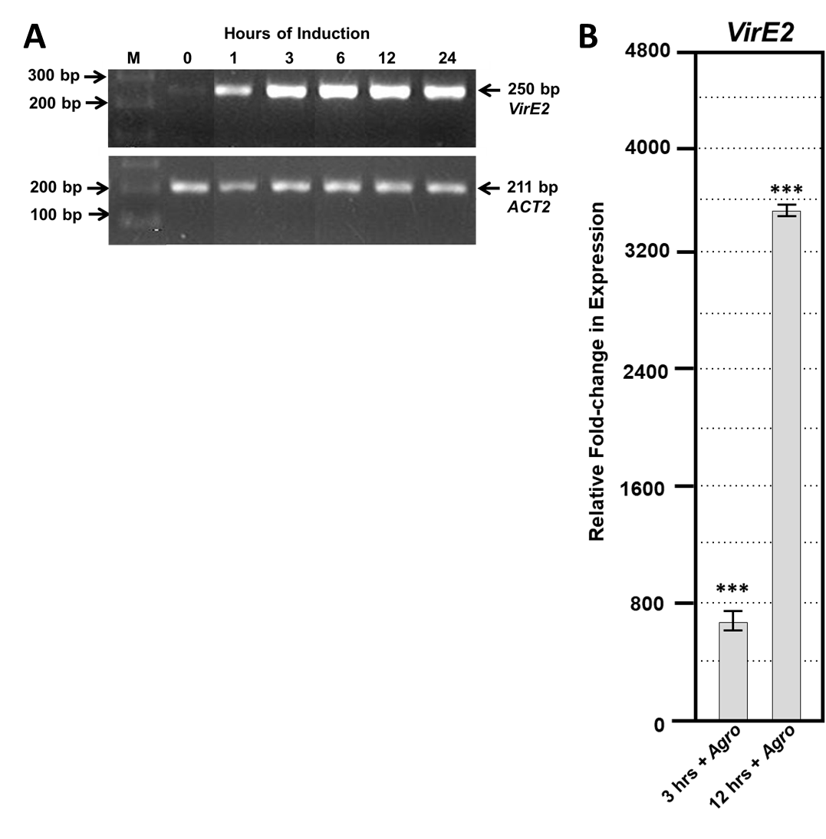
Supplemental Figure 1. Expression kinetics of VirE2 measured by RT and RT-qPCR . (A) A 250 bp PCR product was amplified from the 3’ end of VirE2 transcripts and visualized by ethidium bromide staining after electrophoresis through a 1.5% agarose gel. Samples were harvested 0, 1, 3, 6, 12, and 24 h post-induction with β-estradiol. As a control for RNA integrity, a 211 bp PCR product was amplified from ACTIN2 (ACT2) transcripts. M, size marker; (B) Quantitative RT-PCR of VirE2 gene expression in induced relative to non-induced roots in the presence of A. tumefaciens A136. Results show the average of three technical replicates ± SE. Relative expression is shown after 3 and 12 hr. ANOVA test: *P-value < 0.05, **P-value < 0.01, ***P-value <0.001.

Supplemental Figure 2. Quantitative RT-PCR of selected VirE2 Differentially Expressed Genes. RNA-seq (left) and quantitative RT-PCR (right) results of (A) ADH1 (B) PRKP (C) TAS4, (D) PR, (E) LSU1, (F) LRRPK, (G) AGP21, and (H) NTR2.6 gene expression in induced relative to non-induced roots. Results represent an average of three replicates ± SE for inducible VirE2 Line #10. Relative expression is shown 3 and 12 hours after induction in the presence of A. tumefaciens A136. ANOVA test: *P-value < 0.05, **P-value < 0.01, ***P-value <0.001.

