Figure S3.1. TEM image of Fe₃O₄ NPs
Figure S3.1. Transmission Electron Microscopy image of Fe₃O₄ nanoparticle to confirm the diameter and morphology of particles used in this study. Scale bar = 50 nm

Figure S3.2. Cell Death Following Exposure to Various Concentrations of Fe₃O₄ NP-BC

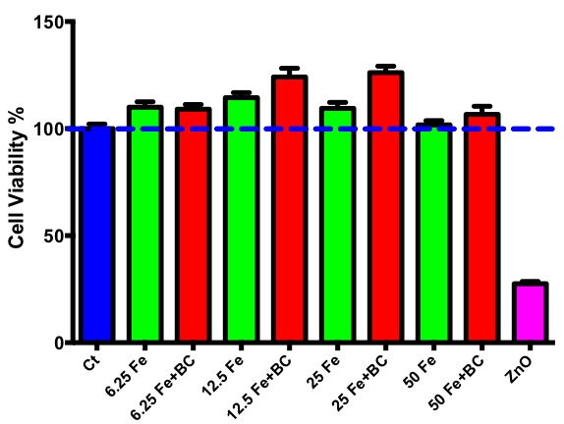

Figure S3.2. Dose-Dependent Cell Viability. Differentiated human macrophages were exposed to “bare” Fe₃O₄ nanoparticles and Fe₃O₄ nanoparticles with a biocorona at concentrations of 6.25, 12.5, 25, and 50 μg/ml, as well as ZnO nanoparticles at 100 μg/ml (positive control). Control cells were untreated. After a 24 hour exposure, an MTT assay was used to assess cell viability. Dotted Line = 100% cell viability.

